**WEB DESIGN**

*Mid Term*

|  |  |
| --- | --- |
| **Course** | Web Design |
| **Exam Type** | **Mid Term** |
| **Duration** | 2 hours |
| **Generation** | GEN-10 |
| **Date** | NOV 20th 2024 |
| **Exam Rules** | * All documents allowed * The following actions are forbidden and will conduct to a 0 score:   + Talking or exchanging information with another student   + Using Internet or any Network |

Evaluation

|  |  |
| --- | --- |
| **Exercise 1** | 20 points |
| **Exercise 2** | 30 points |
| **Exercise 3** | 50 points |

To start

* Read this **document** AND the start **code** (ZIP) from MS TEAM

To submit

* Submit this **document** AND your **code** (ZIP) on MS TEAM

**EXERCISE 1 (20 pts)** *CRITICAL THINKING*

**Q1 – 6 pts**

You need to apply a style to 5 elements on a page.

*Would you* ***use a class, an ID, or a type selector?*** *Justify your choice and explain the potential risks of each method.*

I’d use a class on something that I will use multiple times.

I’d use an ID on something that I will use per time and make it unique from others.

I’d use a type selector on something that I want to select on specifically.

**Q2 – 3 pts**

You are tasked to design a button with an exact width of 100px, including padding and borders.

*Which* ***box-sizing mode*** *should you use,* ***and why****?*

I usually use border-box because it’s easy to style button or something like that.

**Q3 – 3 pts**

You are creating a photo gallery.

*Would you use* ***Flexbox or Grid for the layout****? Explain your decision, considering alignment, responsiveness, and maintenance.*

I’d use flexbox when I want to style my website layout that makes it feels flexible in one dimension like for example navbar.

I’d use Grid when I want to create blocks of content that I want it to make it lines smoothly in two dimensions like for example YouTube videos content.

**Q4 – 3 pts**

You need to add space between a button and the text above it.

*Should you use margin or padding on the button? Justify your choice.*

I’d rather use padding over margin because I only want to resize my content rather than my webpage.

**Q4 – 5 pts**

Here is a website folder structure.

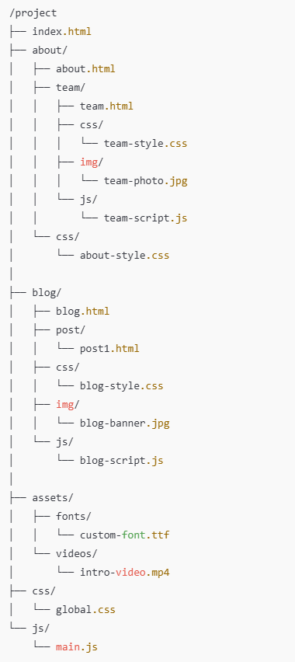

Fill up the table with the **hyperlink**, so that we **can create an anchor link** from the **source folder** to the **destination file**.

|  |  |  |  |
| --- | --- | --- | --- |
| ***PATH TYPE*** | ***SOURCE FOLDER*** | ***DESTINATION FILE*** | ***HYPERLINK LINK*** |
| ABSOLUTE | ./about/team/ | team-style.css | href= ./about/team/team-style.css |
| RELATIVE | project/about/team | blog.html | href= project/about/team/blog.html |
| RELATIVE | project/ blog/css / | team-style.css | href= project/ blog/css /team-style.css |
| RELATIVE | project/ blog/js / | Global.css | href= project/ blog/js /Global.css |
| ABSOLUTE | ./assets/videos/ | intro-video.mp4 | href= ./assets/videos/ intro-video.mp4 |

**EXERCISE 2 (30 pts)**

Design the bellow mock up using a **GRID layout**.

**PART 1** *– Main components – 25 pts*

Design the bellow mock up.

* Your need to change both CSS and HTML
* Use the color as the bellow mockup

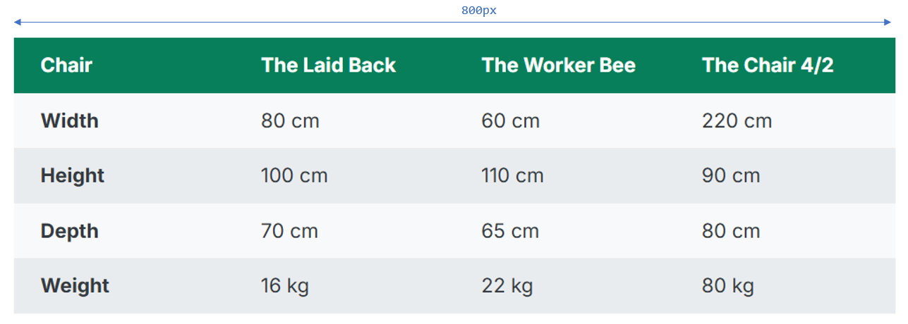

* Each cell should have the same paddings:

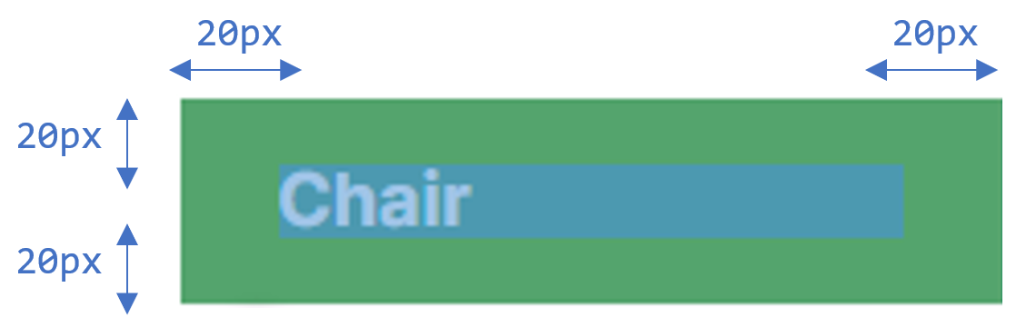

**EXERCISE 3 (50 pts)**

**PART 1** *– Main components – 20 pts*

Design the below mock up using a **GRID layout**. *(No grid layout = no points!)*

* The HTML is provided and **cannot change**.
* *Remaining* means the related row or column **shall stretch** on the available space.

Colors:

* Menu #343a40
* Left Section #7048e8
* Nav #e9ecef

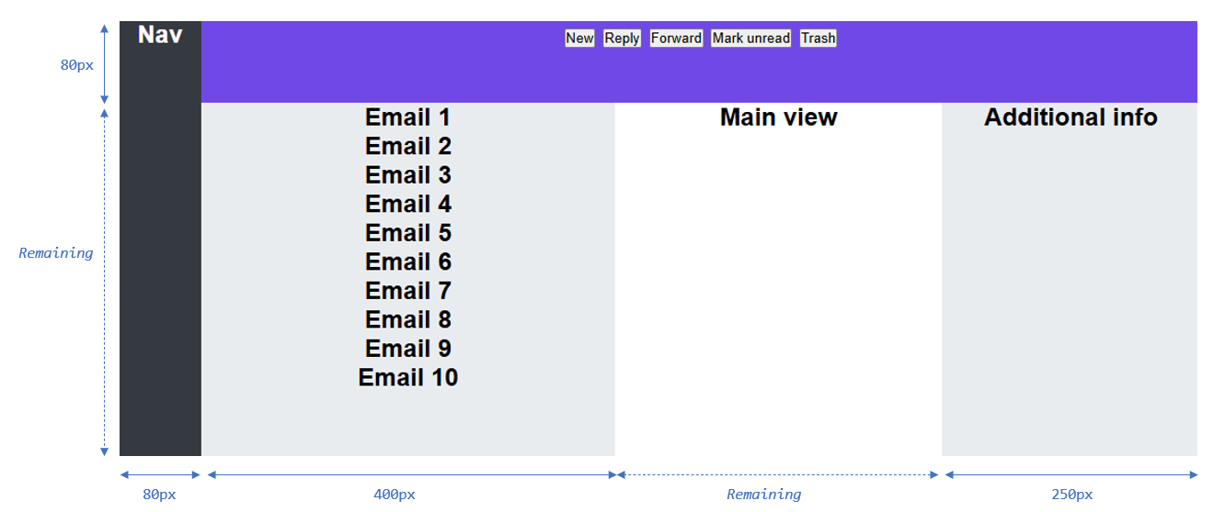

**PART 2** *– Inner elements – 30 pts*

Continue the work by designing the **menu buttons** and **email items**

* Use the types of layouts you want
* Note: the **email section has a scrollbar**: are you able to display it?

Colors:

* Menu button: # 5F3DC4
* Last menu button # d6336c
* Email # adb5bd

